 Slovenské filozofické združenie pri SAV
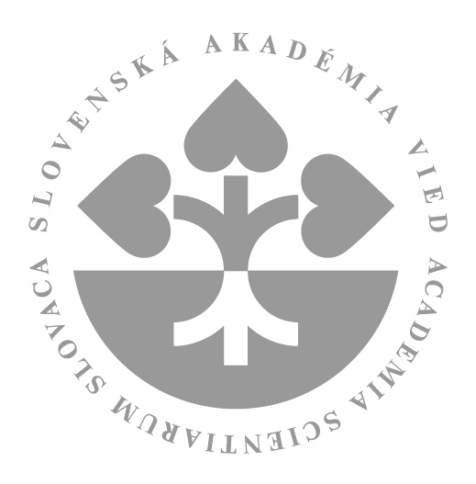 Filozofický ústav SAV

Vás srdečne pozývajú na prednášku

Rafala Smoczynskeho, PhD.
(Inštitút filozofie a sociológie, Poľská akadémia vied, Varšava)
na tému:

"The linguistic turn in Ernesto Laclau's social philosophy"

The paper analyzes the ontological function of language as
articulated in Ernesto Laclau´s social theory. Firstly, Laclau´s argument on the role of the ideological interpellation will be reconstructed, secondly, I will be demonstrated that isolated agency of ideological performativity is not sufficient to introduce a coherent ontological consistency of identity. It will be argued that the intertwine of libidinal force with naming, as the recent developments of this approach suggests, provides the sufficient conditions of the possibility of generating collective identities.

Prednáška sa bude konať dňa 20. 6. 2013 o 14.00 v budove Filozofického ústavu SAV, Klemensova ul.
19, v zasadačke č. 94.

